
March 2025
Frank Russo,

Here Comes the Sun
BUT
There were a few mornings where there was no sun


Photo by Marsha Call Photo by Vicki Tindall

Finally
We Have the Sun

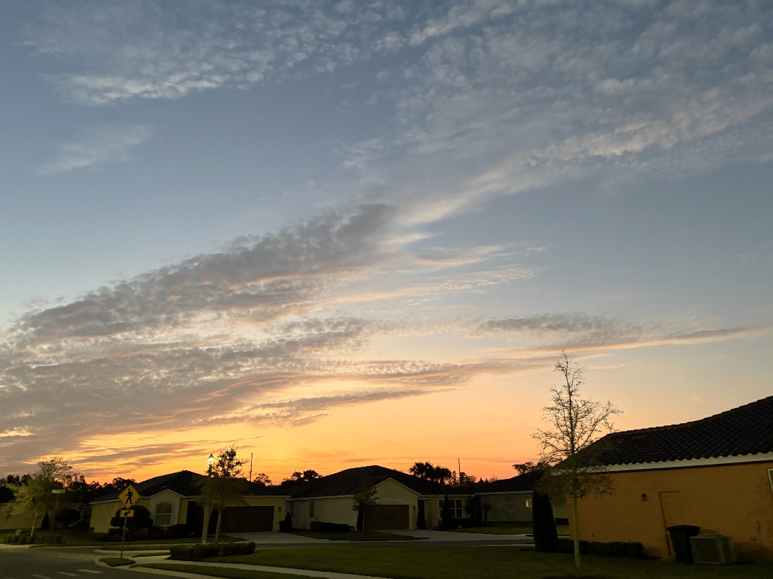

Photo by Marsha Call

Feature Article

Living Alone
By Frank Russo

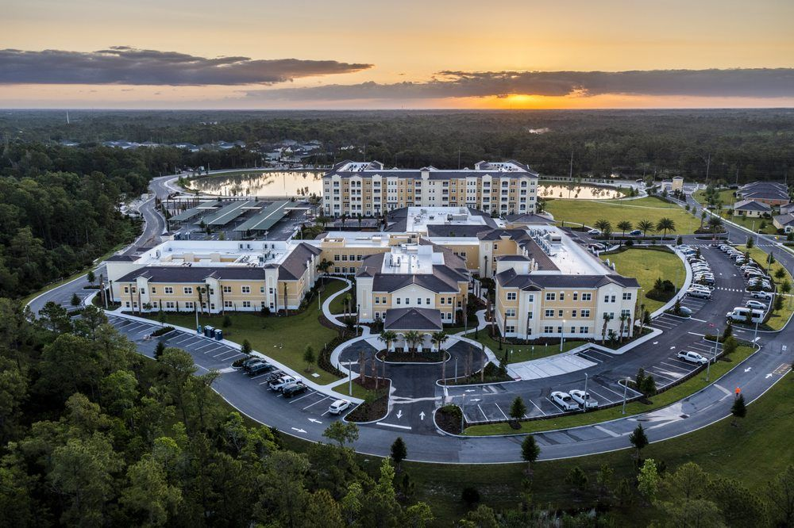

How many times in discussions have you found yourself saying “I live alone”. That sentence conjures up all sorts of thoughts and pictures in the hearer’s mind.
I am recently living alone. My wife died a few months ago. I have used the term “living alone” a few times. And I watched the look on the hearer’s face and eyes. So, I asked several what they were thinking when I said, “living alone”. Several said,” Isn’t it lonely”. One said, “At your age, “Is it safe to be all alone?”.
One said, “Don’t you miss your wife?”

Well, I thought the words ‘living alone’ really did trigger a negative image of ‘alone’ and sensed a ‘feeling sorry for me’ in the hearer’s reply.

So, I thought we needed to change our response. Instead of us saying “I live alone”. How about if we say, “I live single”. That is a whole new reply. “I live single” should get them thinking. Maybe they will ask what that means. And then we can explain what it means to us. Maybe they are thinking, “I’m a swinger”. Not so!

‘Living single” means I don’t have anybody sharing my apartment. But it doesn’t mean that I am ‘lonely’ and need some type of consolation. Like many, but not all of us, we had loving relationships, maybe a family, a job, an important place in our previous communities.

But now living single means that we have a whole new world of opportunities. We have time – unincumbered by other people’s needs – spouses, children, co-workers, etc. Their needs were pressing and sometimes critical.

My status ‘living single’ gives me a new sense of freedom. I have time to make many new friends. I can have dozens. Before, I had time for one or two at most. I can pursue things that I am interested in or that I have always wanted to do.

So, living ‘single’ has all sorts of possibilities. I have the time. The only restrictions I have are those I place on myself. Make the best of it. Don’t fall into the ‘lonely trap’.



SNUG SAFETY

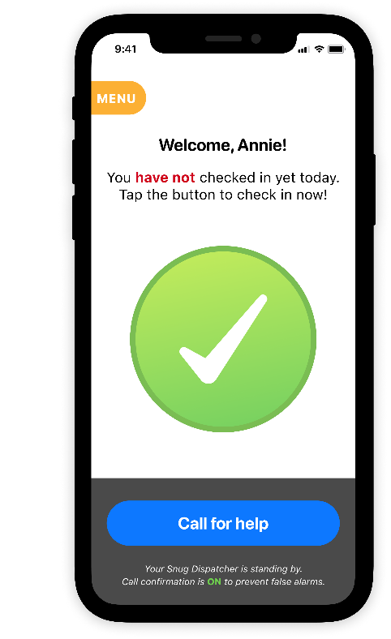

Jon Rogan, one of L.P. residents, has recommended a ‘free’ application for those “living single”. It is called SNUG SAFETY designed for those living single. Its by-line is “on your own but never alone”. It has been featured in the AARP Magazine, The New Yorker, Forbes, and many more.

Download the app. Enter your emergency contacts. Select your daily check-in time. Snug will check with you every day at your selected time. If you are OK press the ‘green button’ to signify that you are ok. If you miss your check-in time SNUG will alert your emergency contacts.

So, this could take the worry out of “living Single”

Featured Event at L.P.

This month’s featured event is the L.P. Golf Indoor Putting Tournament.

Bill Malfitano submitted the following article about the tournament. The pictures were a joint effort by Vicki Tindall and Bill Malfitano. The pictures will appear through this newsletter.

LEGACY POINTE MINI GOLF INDOOR PUTTING TOURNAMENT SUNDAY, MARCH 2, 2025

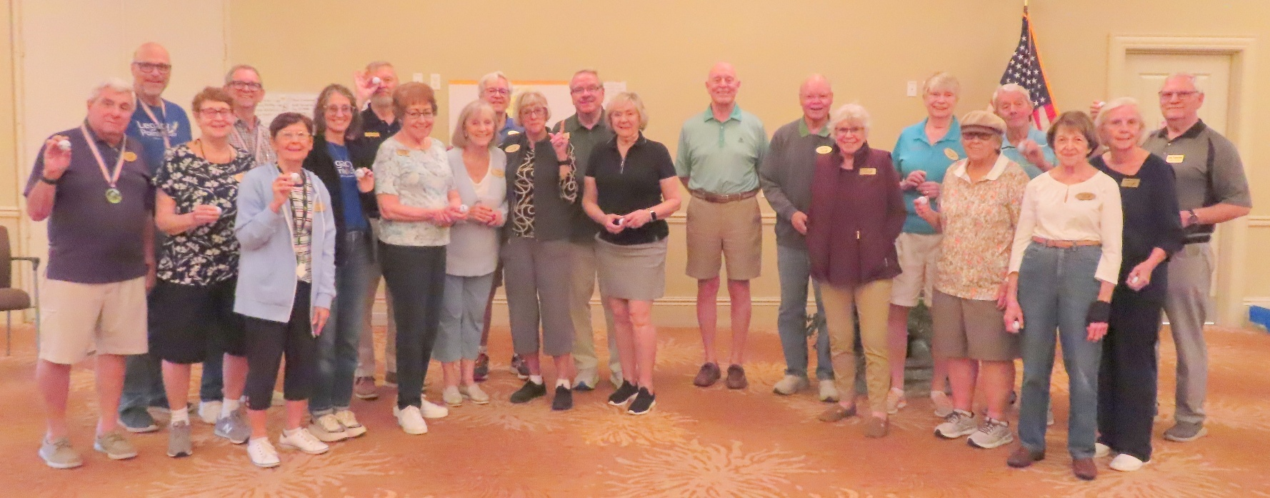

Here are some of the participants who won a prize
On Sunday, March 2, 2025 at 3pm, fifty-four Legacy Pointe Residents gathered in our Auditorium to participate in our indoor putting competition.
Les Tandler, our MC for the event, opened our event with a Welcome and:
- Presented the Rules of the Game and the Layout of the golf course which was posted on the wall in the auditorium.
- Introduced the Legacy Pointe Residents who would be the Golf Marshalls, helping & guiding players in their play.
- And, with a demonstration of play by Doug Healey on a golf hole setup in the Auditorium, announced the official opening of our tournament.
The Golf ‘Marshalls’ then led the players to their designated starting golf holes in our Shotgun start format.
Over the next one and a half hours, golfers navigated the challenges and hazards of our fifteen (15) hole par 3 golf course. Here are the locations

COMMONS
Hole #1 &#2—Legacy Auditorium
HEALTH CENTER
- Holes #3/#4/#5 Rehab
- Hole #6 Clinic
- Hole #7 Administration Hallway
COMMONS
- Hole#8 & #9 Dining Room
- Hole #10 Bistro
- Hole #11 Fitness/Rehab
INDEPENDENT LIVING
- Hole# 12 1st Floor Hallway
COMMONS
- Hole#13 Art Room
- Hole#14 Mail Room
- Hole#15 Card Room

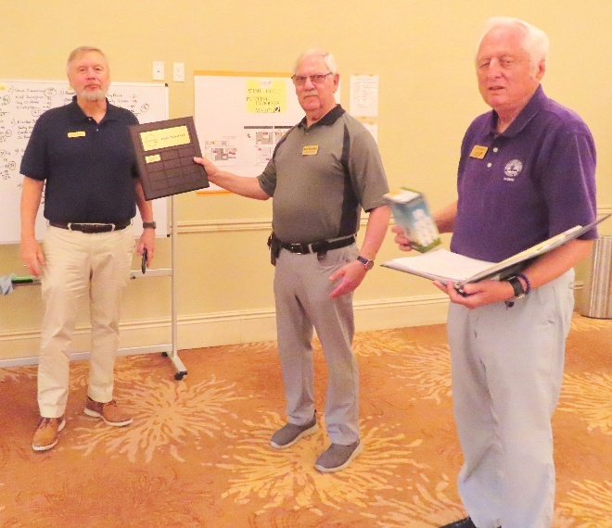

With a great deal of laughter, excitement & agony, over made and missed putts our 54 golfers learned that putting on our Legacy Pointe carpet and hard surface floor was quite a challenge.
At the end of play, score cards were turned in by our golfers. Individual scores were then posted on the whiteboard for everyone to review.
Players and guests moved to the table where they could pick up their meal of a Hot Dog, Chips, Chick-fil-a Cookie and a drink.
We concluded our Golf Event with the Awards Presentations:

Lowest Score of all players---Doug Healey
Women’s Lowest Score---Joanne Kremer
Men’s Lowest Score---Frank DelVero
Highest Men’s Score---Steve Zimmerman
Highest Women’s Score---Joan Battard
Best Team Score---Frank DelVero, Ross Williams, KP Knudsen, David Kremer
Best Bus Driver---Kristopher
Deserving the Best Golf Socks---David & Joanne Kremer
All Hole-In-One Players---Amazingly, 22 players did have at least one Hole-In-One…..their award, a golf ball autographed by David Kremer.

We closed the golf event at 5:30pm with many comments received that, “this has been a lot of fun.”

+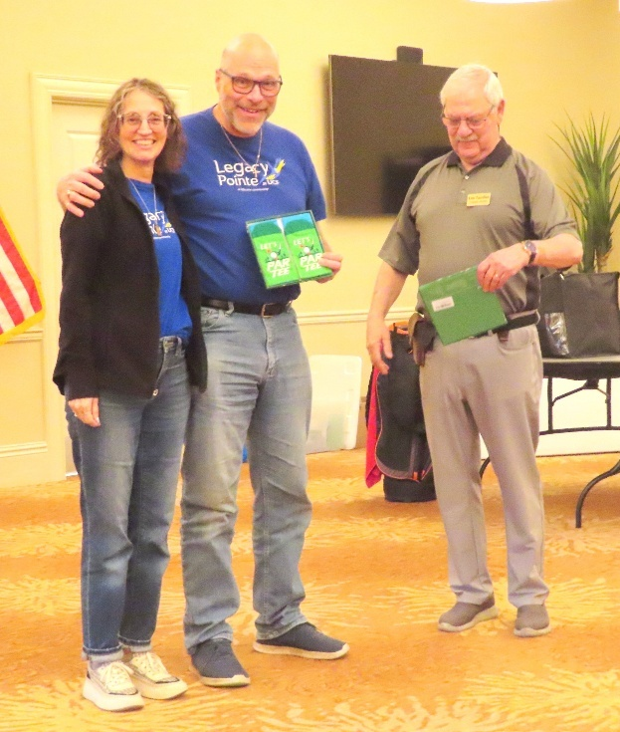

Legacy Point visits the UCF Arboretum.

Two of our residents, Fredi Goodrich and Mary Meeker received an invitation from the Director, Jennifer Elliot, to tour the UCF Arboretum on Thursday March 13th from 5:30 to 7:30 PM. All Legacy Pointe residents are invited to attend

Follow up to our New Years Resolution Article

“National Quitters Day” was on January 18th! On this day approximately 80% of people who made New Year’s resolutions have tapped out by this date. So if you made it past January 18th congratualations you have done more than most people. And if you made it through February you are heroic.

So now it is March. And you are still working on your one resolution. Or you have chosen to do one resolution a month. If so you are on month number three. And resolution number three. You’ve come this far so you know that you can do it. Keep it up!
More Golf Pictures
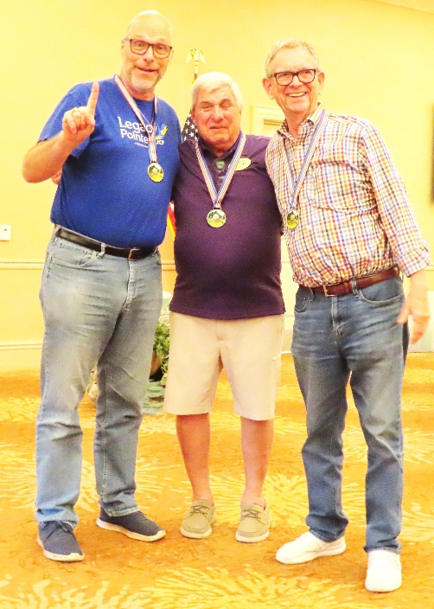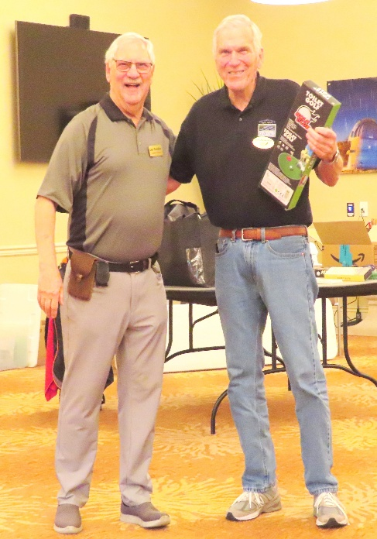

EARTH DAY IS REALLY 365 DAYS
Our Monthly Reminder
Get Ready we will celebrate a New Earth Day here at L.P on Saturday April 19th

EARTH ACTION DAY
The theme for Earth Action Day is Our Power, Our Planet, inviting everyone around the globe to unite behind renewable energy, and to triple the global generation of clean electricity by 2030.
How? By joining us in Earth Day 2025, encouraging all to take action—educate, advocate, and mobilize. Pledge an Earth Action on social media. Attend/plan/register a local event. Integrate Earth Day lessons into your curricula.
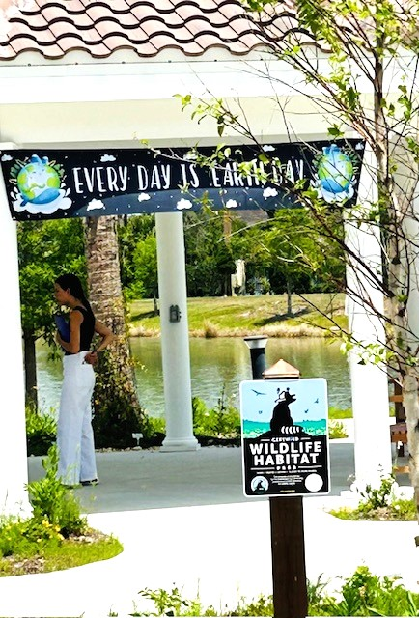
Photo by Maureen Reed

The Theme for Earth Day 2024 is “Planet vs. Plastics”
By Frank Russo
Starting with Earth Day 2024 the LP Independent Times has been focusing on the theme for this year “Planet vs. Plastics”. We have all seen pictures of piles of plastic. We are being buried in plastic. BUT it is not what we can see that is alarming. It is what we cannot see that is a matter of great concern.

Earth day is coming around for its yearly visit near the end of April. That means the LP Independ Times will have just two more feature articles on plastics in our environment and shockingly in our bodies.

In the next two editions we will focus on what science finally finds out about micro and nano plastic particles lodged in our bodies. Unfortunately, since the chemical mega companies were not forthcoming on the dangers of the forever chemical components in plastics, we had no idea of the seriousness and are now under multiple investigations on the dangers of these forever chemicals.

Plastics In Your Brain
If you lived 100 years ago you would have a hard life. Things were difficult just trying to make a living. But one advantage would have been that you would not have plastic particles infiltrating your body and especially your brain.
Plastic was not invented until the late 1940s and didn’t appear in public until the early 1950s. When it did appear, it debuted as Teflon coated pans and Scotch guard as a furniture protective coating. At that time there was no warning that the chemicals used in these, and other similar products would become known as ‘forever plastics’. They never really broke down and dissolved. But they remained as tiny plastics that are now called micro and nano plastics.
There are now over 15,00 combinations of plastics shedding trillions of nano particles all over the world every hour. And they have infiltrated everywhere in every living thing. And this includes you and me.
Just how big is a nano plastic particle? Human hair is approximately 80,000 nanometers wide. A nano plastic particle is between 1 and 1,000 nanometers wide. Just imagine how small that is. It can go unnoticed anywhere in our water, our food chain and our bodies. Yes, it has crossed the brain blood barrier and has found a home in our brains.
If you said that it doesn’t sound good you are correct. Scientists are just starting to find out how bad this is.
One of our residents, Victoria Carpenter, has submitted an article featuring “how bad this is”. Here is the link to the article which appeared in NATIONAL VIEWPOINT by F.D. Flam who is a Bloomberg Opinion columnist covering science.
http://digitaledition.orlandosentinel.com/infinity/article_share.aspx?guid=d77eb460-8331-42b5-8cb0-ecfc7db4f275
Another Brain Article
'Plastics are there and seem to be getting worse': Viral study of microplastics in human brains shows worrisome trend, but has flaws | Live Science
https://www.livescience.com/health/neuroscience/plastics-are-there-and-seem-to-be-getting-worse-viral-study-of-microplastics-in-human-brains-shows-worrisome-trend-but-has-flaws

How to find cleaning products that aren’t full of microplastics
Sharon Lovell, one of our residents, has submitted a link to an article in the Washington Post, by Stacy Colino, featuring these products.

https://www.washingtonpost.com/home/2025/02/20/household-cleaning-products-microplastics/

Update on our Drinking Water

Remember in High School was had to read a poem published in 1798 entitled Ryme of the Ancient Mariner. The only lines we probably remember are

Water, water, every where,
And all the boards did shrink;
Water, water, every where,
Nor any drop to drink.

We could well update those lines with

Water, Water everywhere
And all the chemicals we think
Are in Water, water everywhere
And it’s the only thing to drink

Ina Hunt, one of our residents, has found two articles on chemicals in our drinking water Article on Hazardous Chemicals in our drinking water. The first is by Beth Greenfield. It looks at the national picture. Here is the link:

https://www.yahoo.com/news/truth-american-drinking-water-report-050100704.html
Ina’s second link describes a local report on Seminole County’s water Supply. The word “cancer” causing appears too many times when dealing with the chemicals found in our drinking water.
an item for the newsletter. Do a ctrl-click to access this link

Mardi Gras at L.P.
The residents celebrated Mardi Gras at noon on Tuesday March 4th. The parade started in the lobby and zigged and zagged through the first floor and through AL, MC, SN and back to the lobby


The Mardi Gras Band and Pics by Vicki Tindall

The residents joined in wearing their best Mardi Gras costumes



Members of the Staff joined in also wearing their best Mardi Gras outfits along with a special guest cheerleader

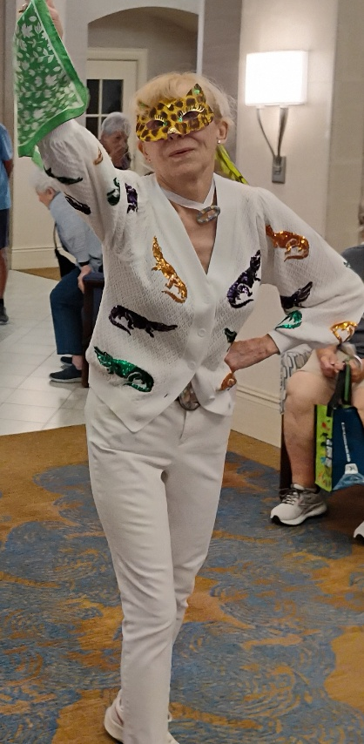

More Golf Pictures

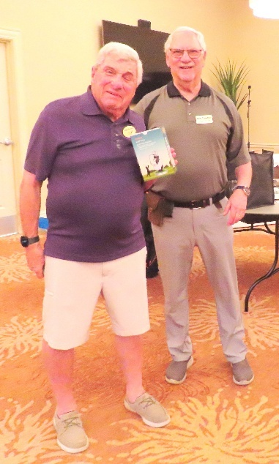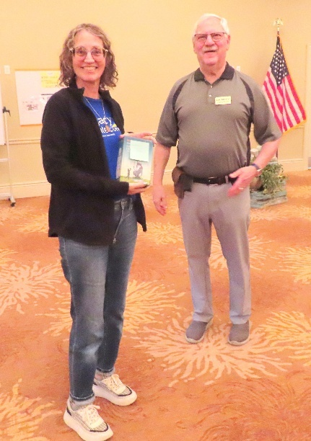

Medicare Changes
By Peg Dunmire

One of our residents, Peg Dunmire, has submitted her comments on Medicare Changes proposed by the current administration. Below is her article

Recently, one of my neighbors was freaking out about potential Medicare cuts. I read a news article today about proposed Medicare cuts. My neighbor would NEVER understand these proposed cuts. I hope I can explain this so all of you will understand.
1. The Federal government funds grants for National Institutes of Health with our tax dollars. If a grant provides medical services to a Medicare eligible patient, then the NIH via the investigator bills Medicare for this medical care. To determine how much Medicare will pay, Medicare establishes rules for what they consider costs. This is how the world of American Health Care works. The payor, Medicare or Blue Cross or Kaiser Permanente determine what they will pay. The provider who provides the care does not determine what the cost is the payor does. (Do you see this is screwed up?).
2. Historically, the grant figures out what its direct costs are: cost of supplies, cost of personnel are examples.
3. But then Medicare allows the provider to include INDIRECT COSTS. They are the costs of the building (depreciation); costs of administration (that expensive CEO). And to make the calculation &quot;easy&quot;, Medicare allows 26% of the direct costs to be added and then that would be considered the INDIRECT costs (this is for ease of calculation and eliminates quibbling over what the CEO is paid).
4. The proposed cut is the REDUCE THE 26% TO 15%. WOW! An 11% cut in the amount Medicare will agree to pay the provider.
What does this mean in English? It means that the government is saying to researchers who have to get permission to perform research from NIH or hospitals or health systems that Medicare will not reimburse &quot;indirect costs&quot; as much as Medicare did last year. That does not cut anything but the providers’ willingness to continue subsidizing a particular grant. Some are lucrative and others are not. Yes, this reduces by 11% reimbursement for the medical care associated with a research project.

Next Month Peg will track the meaning of these “changes -are they really changes”?
More Golf Pictures

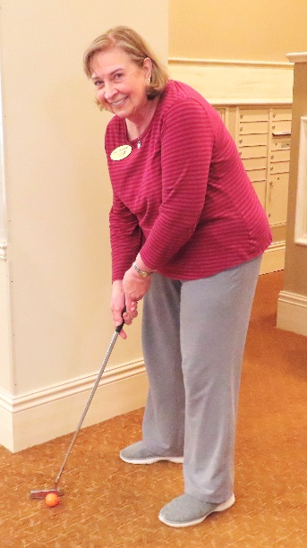

OUR INTELLIGENCE (OI also called HI -Human Intelligence) versus ARTIFICIAL INTELLIGENCE (AI)
by Frank Russo



Our Series on AI is Finished But when an interesting AI article appears the L.P. Independent Times will publish with a little summary. Check out the following article which shows the potential of AI

AI solves superbug mystery in two days after scientists took 10 years
This really hastens development time!
https://www.yahoo.com/news/ai-solves-superbug-mystery-two-151504455.html

Your Resident Council Subcommittees at work
The Culinary Committee
By Polly DelVero

The culinary committee has had two meetings this year and we are pleased with our progress. As we all know, there are many issues that need to be delt with in the kitchen and service in the dining room. We are working closely with Taylor, Renata, and Chef Bobby Graves. Our philosophy is to concentrate on solving a few of the most important issues first.

Our initial concerns are with the food temperature and waiting times to check in. Service in the hours is from 4:30 to 7:00. The effectiveness of the current warming lights is being evaluated. Plates are placed in a hot box to keep them hotter than if they were in the oven.

Taylor is in the process of hiring two additional employees to work on the line. He is also working on getting an expeditor to get the food out faster. It is more difficult to get consistent temperatures to the 8 and 6 top tables.

Renata has her challenges in the dining room. Currently, with reservations not being required, it is difficult to predict the demand and serve food in a timely manner causing longer waiting times. This also puts a burden on the kitchen staff.

The Culinary committee is working on behalf of the residents to improve your dining experience. Please fill out the comment cards on the table as this gives us the opportunity to see what improvements need to be made or what a meal you loved and would like to see again. We read those comments and give the results to the chef. They are helpful!

Please speak to Taylor concerning any of your personal dietary needs.
I appreciate the opportunity to Chair the Culinary committee and hope that we can make a difference to your dining experience.

More Golf Pictures



We Have a Marathon Champion here at L.P. Sandra Hults

The Women’s National ‘Race Walking’ trials were held in Gainesville FL during the last two weeks of February. The track was indoors and was raised at the corners. The track was a rectangle with oval raised corners making it more difficult to navigate, Sandra Hults, one of our residents, who has been race walking for many years, participated in two senior events. The events were the 1,500- and 3,000-meter distances

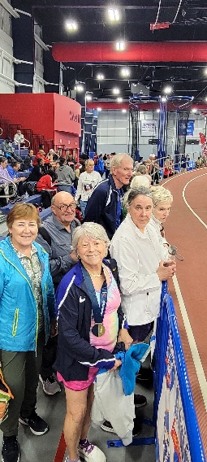
The Gainesville track A few of the walkers

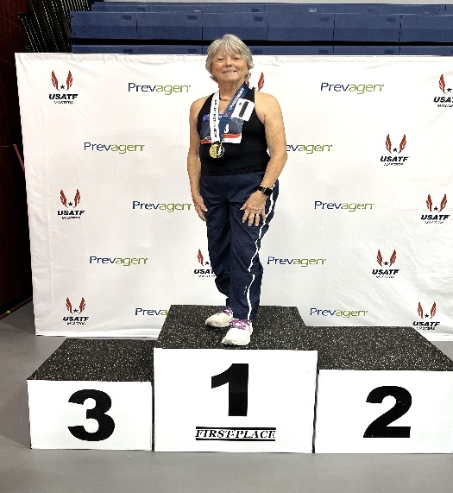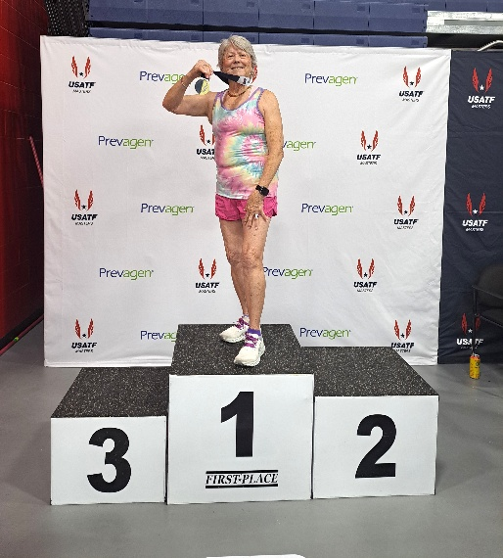

Sandy won the Black 1500 meters Sandy won the Pink 3,000 meters

Race Walking is a precision sport. Speed is important but so is technique. So when you compete you will have at least 5 judges watching your every step to make sure your technique fits into what is required.

Congratulations Sandy!

THE BOSCOLIERS OF LEGACY POINTE

THE BOSCOLIERS OF LEGACY ARE A SMALL GROUP OF NATURE AND HIKING LOVERS.

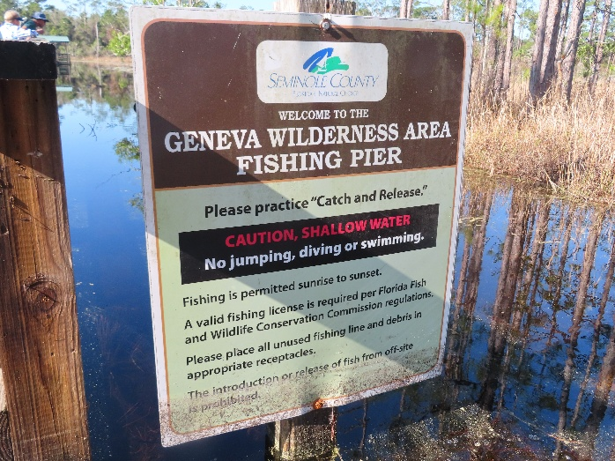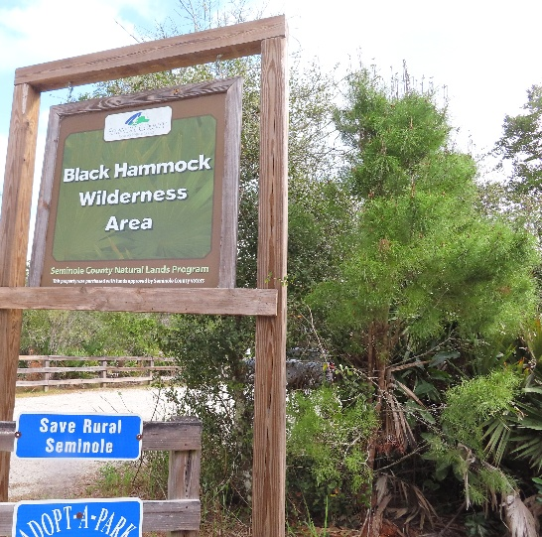

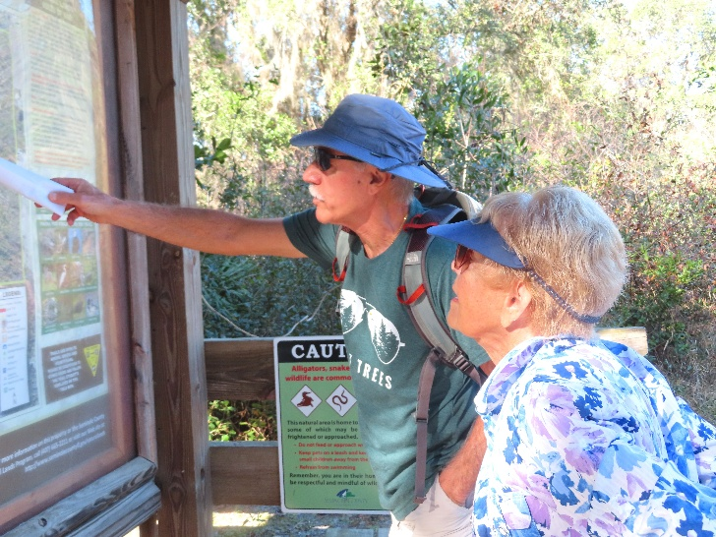

Photos by Vicki Tindall
IF ANYONE IS INTERESTED, I'LL BE HAPPY TO SHARE OUR NATURE PHOTOS - ALL 27 OF THEM - JUST EMAIL ME - TINDALLX2@AOL.COM

The L.P. Women’s Group Organizational Meeting

Seventy women gathered on Sunday March 10th to follow up on last month’s women’s gathering. Peg Dunmire facilitated the gathering.

Residents sat at tables organized by floors/villas. Each table had at least one new resident. One of the goals was to meet the new residents. Eleven out of 32 new women residents were present. The residents appeared to be very engaged in introducing each other to our new residents. Many residents expressed satisfaction with knowing fellow residents on their own floors.

The second part of the meeting was a review of our committees, activities and clubs. Kristina will hold an Activity Fair in June. All leaders of activities/committees/clubs will be invited to set up a booth. Residents will be able to meet with all of our leaders and discuss if the resident wants to get involved with the groups. In addition, we will provide the ability to sign up for additional clubs.

Peg concluded the meeting by recommending no further action in bringing women together for opportunities to get to know each other and form additional interest groups. The floors have active social opportunities. The June Activity Fair will provide an opportunity for all residents to find activities they might want to join.

THE LEGACY POINT BOOK CLUB

The Legacy Pointe Book Club meets on the third Tuesday of the month at 3 PM in the Card Room
Our Book for March 18th is called James by Percival Everett
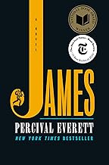
#1 NEW YORK TIMES BESTSELLER• NATIONAL BOOK AWARD WINNER • A brilliant, action-packed reimagining of Adventures of Huckleberry Finn, both harrowing and darkly humorous, told from the enslaved Jim's point of view
When the enslaved Jim overhears that he is about to be sold to a man in New Orleans, separated from his wife and daughter forever, he decides to hide on nearby Jackson Island until he can formulate a plan. Meanwhile, Huck Finn has faked his own death to escape his violent father, recently returned to town. As all readers of American literature know, thus begins the dangerous and transcendent journey by raft down the Mississippi River toward the elusive and too-often-unreliable promise of the Free States and beyond.
While many narrative set pieces of Adventures of Huckleberry Finn remain in place (floods and storms, stumbling across both unexpected death and unexpected treasure in the myriad stopping points along the river’s banks, encountering the scam artists posing as the Duke and Dauphin…), Jim’s agency, intelligence and compassion are shown in a radically new light.
Our Book for April 15th is The Women by Kristin Hannah


Women can be heroes. When twenty-year-old nursing student Frances “Frankie” McGrath hears these words, it is a revelation. Raised in the sun-drenched, idyllic world of Southern California and sheltered by her conservative parents, she has always prided herself on doing the right thing. But in 1965, the world is changing, and she suddenly dares to imagine a different future for herself. When her brother ships out to serve in Vietnam, she joins the Army Nurse Corps and follows his path.
As green and inexperienced as the men sent to Vietnam to fight, Frankie is over-whelmed by the chaos and destruction of war. Each day is a gamble of life and death, hope and betrayal; friendships run deep and can be shattered in an instant. In war, she meets―and becomes one of―the lucky, the brave, the broken, and the lost.
Beer Drinkers Club
The L.P. Bistro took on a new look on the night of Wednesday February 26th at 7 PM. A dozen L.P. residents arrived carrying their brown paper bags. Within minutes bags were emptied, and the tables were covered in beer bottles and cans along with snacks. The first meeting of the Beer Club came to order under the careful eye of the events organizer, Jim Lau.



For the next hour the discussion was about beer and ale. Glasses were passed around so that members could sample the many different brews and flavors.
Come 8 PM discussion ended, leftovers were packed up, tables cleaned. And club members retired.
Next meeting the lasty Wednesday in March on 26th at 7 in the Bistro.
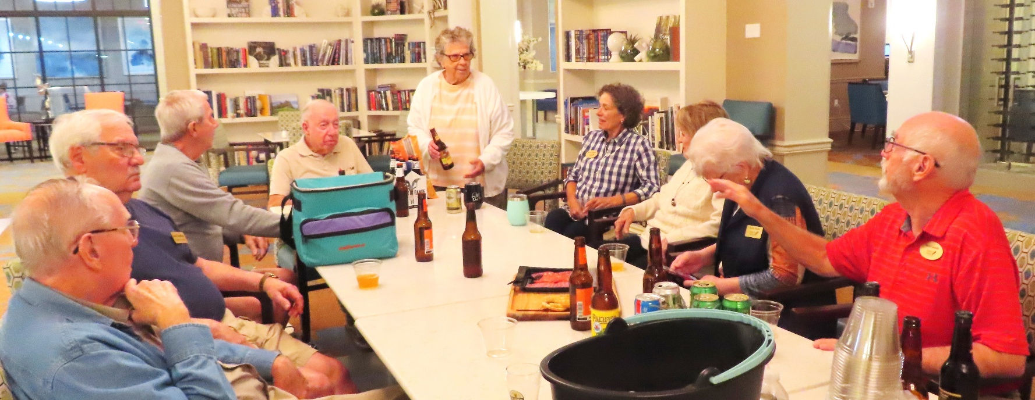



BOCCE BALL 2025 at LEGACY POINTE AT UCF

Bocce has some set times for Games each week they are:
Sunday 3 -4
Monday 11 – 12
Wednesday 11 -12
Saturday 10 -11

You can practice at any other times. The equipment is in the storage container next to the back door coming out of the Bistro and Dining room.

Bill Hornsby Family Picture

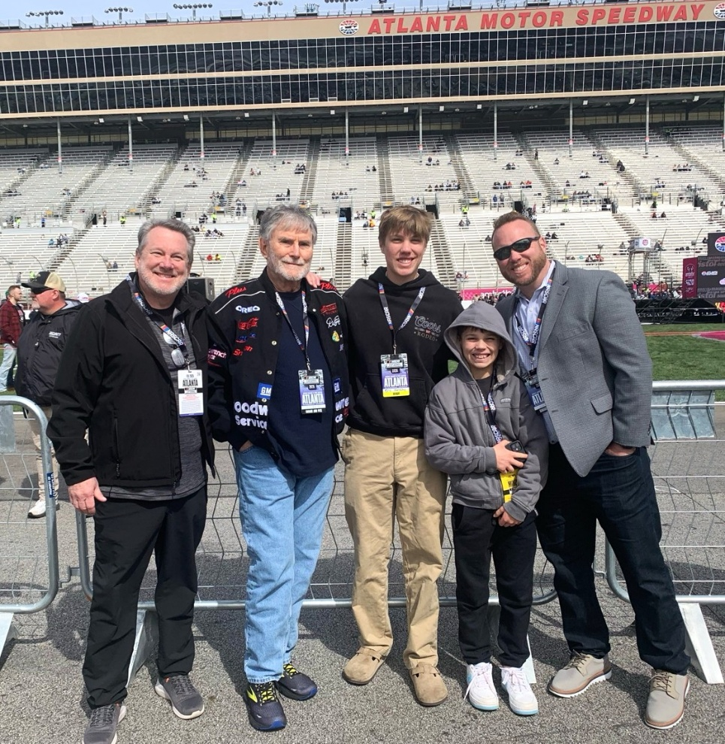

From Left to Right Bill’s son Bob, Bill Hornsby, great grandson Eric, great grandson Elijah, Grandson Eric at Atlanta Motor Speedway.

Have You Ever Heard of Florida Life Care Residents Association?

Probably not. But if you live in a facility that is a contracted continuing care facility you should know about it. It is abbreviated to FLICRA. It is a statewide non-profit association of residents living in Continuing Care Retirement Communities (CCRCs). As residents we have signed continuing care contracts.
These care contracts are regulated as a specialty insurance product by the State Office of Insurance Regulation (OIR). Many of the requirements affecting CCRCs are contained in Florida Statute 651.

During the current legislative session OIR has put forth an Agency Package to make a major changes to Florida Statute 651. One change benefits the residents who will now have some ‘legal standing’ in cases where a CCRC files for bankruptcy. Additionally, this package places many new regulations on CCRCs management and its Board of Directors. These regulations will make doing business more difficult and could place some in financial distress.

Most likely there will be many hours of legislative negotiations which hopefully will reach an acceptable compromise for all parties involved.

Membership fees for residents in FLICRA are

Annual Dues
Single Person: $22.00
Two Persons in a Unit: $37.00

Check their website for further information at
www.flicra.com/about-us/



Bible Study
Monday, March 24 and 31, at 9 AM

The meeting will take place in the Assisted Living Theater, on the second floor
These one-hour non-denominational sessions will be led by Mimi Rodriguez-Thompson, MDiv from Asbury Theological Seminary in Orlando.

The schedule for 9AM March meetings is: March 24 – Led by Mimi, March 31 – Resident-led discussion.

This is a new endeavor that will evolve based on resident input. A Protestant Church Service is also being planned. Questions, comments to:
Tom Nixon btnix64@gmail.com
Sponsored by Lifestyles

LET’S GO TO A MOVIE!
Here are the Legacy Point Movies for March 2025
UniGuest Activities provide a plot summary of each film. Movies are shown in the Auditorium at 6 PM unless otherwise noted.

Date | Time | Movie | Rating | Year | Run Time
Sunday, 3/16/25 | 6 | Once | R | 2006 | 1h 26m
Sunday, 3/23/25 | 6 | Witness | R | 1985 | 2h 6m
Sunday, 3/30/25 | 6 | Cat Ballou | NR | 1965 | 1h 37m
Sunday, 4/6/25 | 6 | The Legend of Bagger Vance | PG13 | 2000 | 2h 6m
Sunday, 4/13/25 | 6 | The Gods Must Be Crazy | PG | 1980 | 1h 49m
Tuesday, 4/15/25 | 4:00 | Movie Committee Meeting - 4PM (1 time only) |  | --- | ---
Sunday, 4/20/25 | 6 | Last of the Mohicans | PG13 | 1992 | 1h 54m
Sunday, 4/27/25 | 6 | The People We Hate at the Wedding | R | 2022 | 1h 40m
Sunday, 5/4/25 | 6 | Under the Tuscan Sun | PG13 | 2003 | 1h 52m
Sunday, 5/11/25 | 6 | The Net | PG13 | 1995 | 1h 54m
Sunday, 5/18/25 | 6 | Animal House, National Lampoon | R | 1978 | 1h 46m
Sunday, 5/25/25 | 6 | The Big Easy | R | 1987 | 1h 36m

GARDENER’S CORNER
“We Come From The Earth
We Return To The Earth
And In Between We Garden”
By Alfred Austin
Gardening on your balcony
Many Legacy Pointe residents would like to grow something but do not want to garden outside. So, the Gardener’s Corner will try to offer suggestions for things you can grow on your balcony.
If you are new to gardening let’s start off easily. How about a tomato plant, a pepper plant, 2 green bean plants, and some lettuce plants.

The start time is mid-March when it warms up a bit.
NOTE do not go out and buy seeds. Garden club members will lend you seeds. Contact Frank Russo at 407-341-7622 to ask for help and seeds.

Here is what you will need in March. (DO NOT SPEND MUCH MONEY)
You will need several large buckets to transfer seedlings. (Buy buckets at Dollar Tree based on the number of seeds you are transplanting. These cost $1.25 each versus what you would spend at a nursery which could cost $10 each. Punch 3 holes in the bottom of each bucket for drainage and you have your ‘pot’ for growing each of your plants.
Here are instructions for transplanting to larger bucket. If your seeds have sprouted and have several sets of leaves it is time to transfer them. Remember above we recommend going to a dollar tree store to buy some gallon buckets. Punch 3 holes in the bottom for drainage and you are ready to start transplanting.

Bean Seeds
- Be careful with your Bean seedlings when transplanting to a larger container. They do not like to be disturbed. Add a mixture of potting soil and garden soil to your 2 new buckets about 2/3 full.
- Carefully tap you bean seedling from their dixie cups and after making a hole in the middle of your mixture put the bean seedling into the soil. And gently firm up. (Note do not put more than one seedling per bucket discard extra seedlings).
- Watering Use just enough to keep the soil moist but not super wet.
- Set your bucket near your screened railing, (I put mine raised up on blocks to let air flow underneath – I use concrete bricks. Cost about 70 cents at Home Depot or Lowes.
- If you did not start beans in dixie cups you can plant one seed for each of your bean buckets. They will sprout within a week and grow quickly
Grape Tomato Seedlings
- Carefully tap you Tomato seedlings from their dixie cups and after making a hole in the middle of your mixture put the tomato seedling into the soil. And gently firm up. (Note do not put more than one seedling per bucket discard extra seedlings).
- Water Use just enough to keep the soil moist but not super wet.
- Set your bucket near your screened railing, (I put mine raised up on blocks to let air flow underneath).

Pepper Seedlings
- follow the same instructions for tomato above. Pepper seeds are very slow to germinate and need warm soil to do so. So, they may need extra time before transplanting.
Lettuce.
1 You can tap your lettuce seedlings from their dixie cup.
- Gently separate them and plant them into your bucket leaving a good 3 to 4 inches between them. You can also plant lettuce seeds directly into your bucket spacing 3 to 4 inches.
Keep your plants watered daily if the soil starts to dry. Use the finger test to check the moisture level. If your second knuckle comes out dry it is time to water. NOTE as it gets hot (May, June, July) you may be watering twice a day.
Sit back and enjoy.

Cleaning up your baking sheets

If you cook, you will need to clean up your baking sheets from time to time. Here is an article that may make it easier
How to Clean Dirty Baking Sheets So They Look Brand New
https://www.yahoo.com/lifestyle/clean-dirty-baking-sheets-look-160000303.html

Recipes

Cornbread is a special ‘southern’ tradition. And every family has their own recipe passed down from generations. One thing that they have in common is using ‘cast iron’ pans for their treasure.

However, there is one very large group of cornbread lovers who do not have the time for complicated traditions. They are the southern firefighters. It has to be quick because nobody knows when the bell is going to ring. Below is their quick cornbread recipe. Don’t be shocked.



https://www.simplyrecipes.com/firefighters-secret-to-the-best-cornbread-8705774

SOCIAL, PHYSICAL, & NUTRITIONAL ASPECTS OF “SENIOR LIVING”
Shared for your interest … we do not make any claims or recommendations.
We welcome articles and videos that you see on the web concerning health issues we all face in our environment and especially in our food. Processed foods are the real health dangers since they contain many different chemicals and dyes..
If you find interesting articles forward them to me at frankrusso2012@gmail.com

Seniors’ Nutrition Information, Your Guide to Eating Well
9 of the Best Vegetables to Eat for Protein
There have been many articles on the web recently featuring ways to get protein without depending on animals. Here is a link to one of them.
https://www.marthastewart.com/vegetables-with-protein-8785071
POETRY
Several residents have asked if we can find residents who write poetry and would like to submit to the newsletter to be published. If you are a poet, send us some samples to frankrusso2012@gmail.com

DO YOU NEED TO GET OUT AND DO SOMETHING?
Do you want to take a little trip for a change of scenery? Check out these 25 suggestions for short trips from Oviedo!
https://www.orlandoweekly.com/orlando/25-easy-weekend-road-trips-from-orlando-everyone-should-do-at-least-once/Slideshow/35988297/35989533

IF YOU DON’T WANT TO LEAVE LEGACY POINTE …
Check out Kristina Ferry's weekly Activity email postings to LP residents! See also the daily/weekly Activities section in the UniGuest app.
Here are some of the many available clubs and activities to participate in:

- Arts & Crafts: Artist’s Club; Blanketeers Workshop

- Dance: Dance Club; Line Dancing

- Exercise: Aqua Aerobics; Low Impact Cardio Dance; Sunrise Tai Chi; Chair Fit; Silver Sneakers; Yoga (Seated, Chair and Mat versions)

- Fun & Games: Bridge (Casual; Practice Group; Evening Group); Canasta; Chess; Game Night; Mahjong; Mexican Train Dominoes; Spade

- Gardening: Garden Club

- Literary: Book Club; Writer’s Group

- Music: Recorder (wind instrument) Class; Voices of Legacy Choir

- Veterans: Veterans Special Interest Group(s)

FYI ~ THE LP NEWSLETTER LOGO

The blue and yellow leaves represent Legacy Pointe's colors.

The green leaves (growing higher) represent the continuing growth provided by our residents.

This beautiful design was created by LP resident Jonathan Wahl.

SURFING THE INTERNET

You could spend your whole day just sitting and surfing. If you do this your entire body will fall apart from lack of exercise. So, our newsletter is asking its readers who spend just a few minutes a day surfing to send along some links to articles that may be interesting or funny or extremely important. Send links to Frank Russo at frankrusso2012@gmail.com

This month’s surfing produced a number of articles about science discovering ways to control ‘super bugs’ that cannot be treated with current antibiotics. One method involve turmeric which proved very effective. The article is a little on the medical technical side, but it is interesting; Here is the link.
Warding Off Superbugs with a Pinch of Turmeric | Texas A&M University Engineering
(use Ctl-Clk on the link)

Feedback? Stories? Photos?
Send to Frank Russo at frankrusso2012@gmail.com

SPACE LAUNCHES AT KENNEDY SPACE CENTER FOR MARCH 2025

There are many launches scheduled this month and next click on the link below to get the days and times


Photo by Joyce Swing

For list of all Launches check this website suggested by John Boldt.
https://nextspaceflight.com/launches/

THE LEGACY POINTE RESIDENTS FORUM

Remember to SIGN UP for the LP Residents Forum!
https://lpresidentsonline.org/smf

You can easily set up your login and password. The Forum is a place for you and your neighbors to come together . . . To create a knowledge base . . . To go beyond a community to becoming a family. We hope to see you online soon. If you need help, email Forum Administrators Jonathan Wahl 47ipsd@gmail.com or Ina Hunt utgrad@attglobal.net

And in case you missed any issues, click the following link to access the complete Newsletter Archive: LP Residents Forum - Residents Newsletters (lpresidentsonline.org)

Please check out In Memoriam, the latest Category on your Legacy Pointe Forum. It is a place where we can express our love and memories of cherished members of our Legacy Pointe Family who are no longer with us. A place to celebrate their lives and ensure they will not be forgotten. And a place to draw comfort from our shared memories. Please feel free to share pictures, stories, memories, tributes, and obituaries. To Create a memorial, click New Topic and type the person's name. To add your sentiments to an existing memorial, click Reply.
If you have any questions, please contact Forum Administrators Jonathan Wahl or Ina Hunt (email addresses above).

OUR DAY ENDS

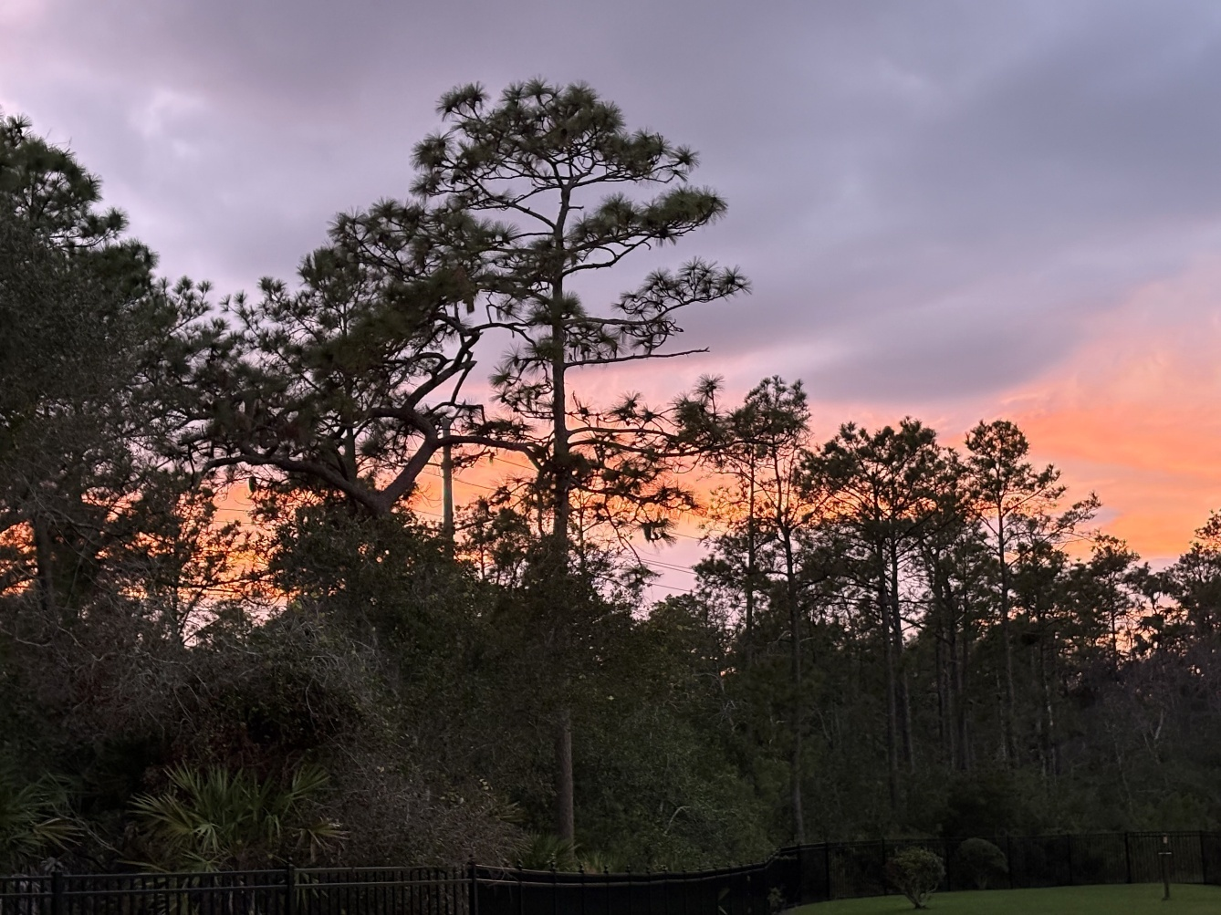

Sunset by Marsha Call

